**MAJOR PROJECT REPORT ON “PERFORMANCE EVALUATION OF VAPOUR COMPRESSION**

**REFERIGERATION SYSTEM WITH INTEGRATED MECHANICAL**

**SUB-COOLING’’**

*Submitted in partial fulfilment of the requirements for the award of the degree of*

**BACHELOR OF TECHNOLOGY** **IN** **MECHANICAL ENGINEERING**

Submitted by

**Abhishek Aggarwal (35114808220)**

**Arunav Sharma (75214808220) Pawan Kumar (00514808220)**

**Amit Singh Bisht (00114808220) Rishabh Jain (20114811119)**

**Narendra Singh (00414808220)**



DEPARTMENT OF MECHANICAL ENGINEERING

**MAHARAJA AGRASEN INSTITUTE OF TECHNOLOGY**

PSP AREA, PLOT NO. 1, SECTOR-22, ROHINI, DELHI-110086 2022-2023

**DECLARATION**

We hereby declare that this submission is our own work and that, to the best of our knowledge and belief, it contains no material previously published or written by another person nor material.

The project report entitled **“PERFORMANCE EVALUATION OF VAPOUR COMPRESSION REFERIGERATION SYSTEM WITH INTEGRATED MECHANICAL SUBCOOLING’’,** For the award of Bachelor of Technology in Mechanical Engineering and submitted to the Department of Mechanical Engineering is an authentic record of my own work carried out under supervision of **Dr. Vaibhav Jain Sir, H.O.D,** Department of Mechanical Engineering.

**Abhishek Aggarwal (35114808220)**

**Arunav Sharma (75214808220)**

**Pawan Kumar (00514808220)**

**Amit Singh Bisht (00114808220)**

**Rishabh Jain (20114811119)**

**Narendra Singh (00414808220**

**CERTIFICATE**

This is to certify that the project work done on **“PERFORMANCE EVALUATION OF VAPOUR COMPRESSION REFERIGERATION SYSTEM WITH INTEGRATED MECHANICAL SUBCOOLING’’,** submitted to Maharaja Agrasen Institute of Technology, Rohini (Sector-22), Delhi by **Abhishek Aggarwal (35114808220), Arunav Sharma (75214808220),** **Pawan Kumar (00514808220), Amit Singh Bisht (00114808220), Rishab Jain (20114811119), Narendra Singh (00414808220)”** in partial fulfilment of the requirement for the award of degree of Bachelor of Technology, is a bonafide work carried out by him under my supervision and guidance . This project work of original work and has not been submitted anywhere else for any other degree to the best of my knowledge.

Signature

Dr. Vaibhav Jain

(H.O.D, ME)

## ABSTRACT

**Vapour-compression refrigeration** or **vapor-compression refrigeration system** (**VCRS**), in which the [refrigerant](https://en.wikipedia.org/wiki/Refrigerant) undergoes [phase changes,](https://en.wikipedia.org/wiki/Phase_transition) is one of the many [refrigeration cycles](https://en.wikipedia.org/wiki/Refrigeration_cycle) and is the most widely used method for [air conditioning](https://en.wikipedia.org/wiki/Air_conditioning) of buildings and automobiles. It is also used in domestic and commercial refrigerators, large-scale warehouses for chilled or frozen storage of foods and meats, refrigerated trucks and railroad cars, and a host of other commercial and industrial services.Oil refinerie[s,](https://en.wikipedia.org/wiki/Oil_refinery) [petrochemical](https://en.wikipedia.org/wiki/Petrochemical) and [chemical](https://en.wikipedia.org/wiki/Chemical_plant) processing plants, andnatural gas [processing](https://en.wikipedia.org/wiki/Natural_gas_processing) plants are among the many types of industrial plants that often utilize large vapor compression refrigeration systems. [Cascade refrigeration](https://en.wikipedia.org/wiki/Cascade_refrigeration) systems may also be implemented using two

**CHAPTER –1 INTRODUCTION**

In this chapter, the introduction of VCRS will be focused on. The basic VCRS cycle and how it works will be discussed, as well as its advantages and disadvantages. Methods of improving the COP of the system will also be reviewed. The chapter will be concluded by telling about the motivation of the project.

**1.1 Introduction**

The most widely used technology in the modern world is refrigeration . Refrigeration systems are extensively used in countries near to equator, such as India , Bangladesh, Pakistan and many ASEAN countries. They are a major industry in countries surrounded by dessert like Saudi Arabia , Dubai and other gulf countries.

The most common cycle used for refrigeration is the Vapor compression refrigeration cycle (VCRS).The reasons for its wide usage is the optimum efficiency and its long reliability which makes it the best technique for refrigeration.

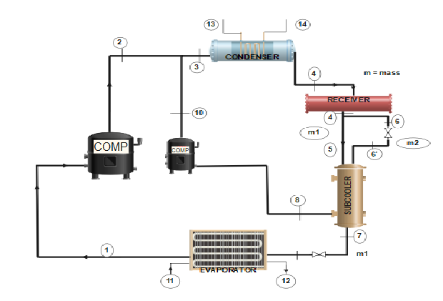

Figure 1:- VCRS system

**1.2 WORKING**

In the VCRS cycle, a refrigerant is used to absorb and reject heat at different locations. A liquid, called refrigerant, is used, which undergoes a change in its phase from liquid to gas and then back to liquid. The changes in the phases require heat absorption or rejection. Heat is absorbed from the heat source and is then rejected to the atmosphere.

The main components of VCRS include condenser, evaporator, expander and compressor. These components are fitted with safety devices like receiver etc.

After coming from evaporator refrigerant passes through compressor where it is compressed which will increased its pressure and temperature. The compression is followed by condenser. the condenser extracts heat from the refrigerant. Then the refrigerant pass-through expander which lowers the pressure and temperature of the refrigerant. Finally, the refrigerant passed through evaporator which is connected to heat source. Heat is absorbed from heat source by refrigerant. The refrigerant changes its phase form gas to liquid.

Advantages of VCRS

* The cycle is compact with less components
* Less rotating components. hence less complexity
* Less refrigerant is used in 1 cycle. So, maintenance cost is less
* The coefficient of performance of cycle is high
* Since while evaporation temperature remains constant. so efficiency of cycle is high Disadvantage of VCRS
* The setup cost is high.
* The refrigerants used is expensive
* The refrigerant used is not environment friendly. The research is still going to find an economical refrigerant
* The leakage issue should be prevented as it can be hazardous for people and environment

**1.3 Method of improving VCRS**

Techniques for improving COP of VCRS

**(i) Flash Chamber addition** :- The flash chamber is added after the expansion valve. The need for flash chamber is the unwanted vapour that are generated after expansion. These vapours are transferred in compressor the flash chamber consists of an insulating tank. The load should remain fixed for insulating tank.

**(ii) Accumulator addition** :- The accumulator is responsible for supplying only liquid to evaporator. The use of accumulator is when the load is varied though out the period. This improves the efficiency of the system and keep heath of components good. The accumulator is made from a insulating tank. A baffle plate is used for vapour striking. It is fitted between expansion device and evaporator.

**(iii) Using subcooling method to improve COP** :- Subcooling is called for a liquid at a temperature below its melting point. Refrigerant has subcooling stage, so that engineer’s should know how much to subcooled. The technique can take place in heat exchanger or in the pipe of entry of expander.

**1.3.1 Types of subcooling**

**Integrated mechanical subcooling**- In the integrated mechanical subcooling, A small VCRS cycle is connected by main cycle. The cycle is called subcooled cycle. The cycle use main condenser to reject heat. The method is widely used in subcooling techniques and under research.

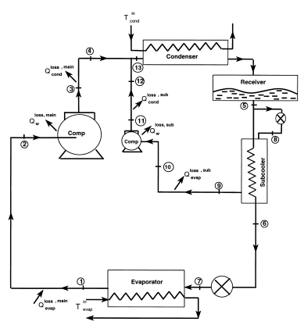

Figure :- Integrated mechanical subcooling

**Dedicated mechanical subcooling**- In the dedicated mechanical subcooling cycle, a small cycle called as subcooled cycle is connected to main cycle to provide subcooling. The temperature and amount of subcooling can be directly related to the small cycle temperature. The method is used in industry but it has some limitations and advantages.

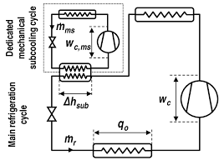

Figure :- Dedicated mechanical subcooling

**1.4 MOTIVATION FOR PROJECT**

The Future of VCRS is the subcooled cycle. The VCRS is the most widely used cycle . it is accepted all over world. There has been no major breakthrough in refrigerating which can replace VCRS. But improving the efficiency of cycle can benefit manufactures and people. The concept of subcooling is quite intriguing.

The team’s motivation of doing research project has always been the idea of creating something new that can benefit the world. I expect by this project we can contribute something to the world.

The research can also benefit the researchers who are working in this field.

**Chapter - 2**

**Literature Review and Survey**

The major focus of this chapter is to provide a summarized information which we have taken from the earlier studies and works published in the various research paper. Also what objective we have.

**2.1 Summary of literature review**

The literature review or the survey regarding the dedicated and mechanical integrated subcooling has shown that subcooling has helped in the enhancement of the performance of the system. It can be said on the basis of comparison of the system and the comparison of the refrigerants which we had come across. Like simple using the subcooling and the using the refrigerant likes of R717 or R134a. Various condition are made in the EES system to find out proper results for the comparisons and analyses.

**2.1.1 Literature review on dedicated sub cooling**

**(Exergy analysis of dedicated mechanically subcooled vapour compression refrigeration cycle using HFC-R134a, HFO-R1234ze and R1234y. By: Shyam Agarwal, Akhilesh Arora, and B. B. Arora)**

From this paper it was observed that the dedicated mechanically subcooled vapour compression refrigeration system is an improved version of simple VCR cycle. Overall performance of the improved version is better than the simple VCR cycle. It was done on the calculation and computation model developed in the EES. The comparison is on the basis of variation of the effectiveness of the subcooler (0.3-1.0) and isentropic efficiency of compressor (0.1-1.0). Exergy destruction in each component of system is also checked. The refrigerants used was HFC-R134a, HFO-R1234ze, and R123yf. It was observed that HFO-R1234ze competes with the other two. It also shows HFO-R1234ze as a good alternate to R134a.

**(Experimental energetic analysis of a vapour compression refrigeration system with dedicated mechanical subcooling. By: Bilal A, Qureshi, Muhammad Inam, Mohammed A. Antar and Syed M. Zubair.)**

The result of this paper shows that dedicated subcooling can be used for increasing cooling efficiency. The Experimental set up shows that load carrying capacity of the evaporator increased approximately 0.5kw when the refrigerant R22 was subcooled in the main cycle by 5-8 degree C. Experimental setup has two refrigerants, R12 flowing in the dedicated subcooling cycle. Also the second law of efficiency increased by an average of 21%, when the subcooling was done. The trend has also indicated that this percentage increase in the efficiency is inversely proportional to the ambient temperature variation. In this set up experimental comparative analysis is done. The setup used for this investigation is a dedicated mechanical subcooling system with 1.5-ton simple vapour compression is presented refrigeration system.

**(Dedicated subcooling design strategies for supermarket applications. By: J.W. Thornton, S.A. Klein, J.W. Mitchell)**

An ideal subcooling cycle was used to predict the optimum value of subcooling evaporator temperature, which can be compared with result obtained from the property dependent model. The overall performance improvement is directly related to the temperature of the evaporator of the sub cooling cycle.

**(The effect of refrigerant combination on performance of a vapour compression refrigeration system with dedicated mechanical subcooling. By: Bilal Ahmed Qureshi, Syed M. Zubair)**

R134a produced the best results for COP and the size of the compressor when used in the main cycles and the dedicated cycle. Which was lower when R717 used in the dedicated cycle. Which make use of R134a more suitable in dedicated mechanical subcooling

**Energy improvements of CO2 transcritical refrigeration cycles using dedicated mechanical subcooling**

In this paper for energy performance of CO2 transcritical refrigeration systems using a dedicated mechanical subcooling cycle are evaluated for three evaporating levels (5, -5 and -30 ºC) for environment temperatures from 20 to 35 ºC using propane as refrigerant for the subcooling cycle. It show that the COP up to a maximum of 20% and the cooling capacity up to a maximum of 28.8%, being both increments higher at high evaporating levels.

**Literature review on experimental dedicated sub cooling**

**Experimental energetic analysis of a vapour compression refrigeration system with dedicated mechanical sub-cooling**

In this work, we analysis dedicated mechanical subcooling cycle with a residential 1.5 ton simple vapour compression refrigeration system cycle performance is conducted with and without the dedicated subcooler cycle when the room temperature is kept between 18 and 22 C. R22 is employed as the refrigerant in the main cycle whereas R12 is flowing in the dedicated subcooling cycle. The experimental work proves that dedicated subcooling can be used for increasing cooling capacity and efficiency

**Experimental determination of the optimum working conditions of a commercial transcritical CO2 refrigeration plant with a R-152a dedicated mechanical subcooling**

In this work, Transcritical CO2 plants combined with subcooling systems are the focus on the improving their performance. Among the subcooling systems, the Dedicated Mechanical Subcooling system (DMS) to improves the overall COP and the cooling capacity of the system. Here we use R152a as a refrigerant. And plant was tested at different pressure and subcooling conditions in order to determine the working conditions where the COP of the plant is maximum.

**2.1.2 Literature review on integrated subcooling**

**(Thermodynamic analysis of a vapour compression refrigeration system integrated with a subcooler cycle. By: Ranendra Roy and Bijan Kumar Mandal)**

From this paper the cooling load of the system was predicted to increase nearly 11%, when subcooler is added to the system. Also the COP and exergetic efficiency was founded to be better and the exergy destruction rate decreased when the subcooler is associated with the system. The increase in the COP of the system with subcooler founded to be 11.4% and 16% at 0degree and -10 degree respectively. The decrease in the exergy destruction rate was founded to be 17.8% and 8.8% at evaporator temperature of 0 degree and -10 degree.These observations are made after the analyzing and comparing a mathematical model with and without the subcooler loop based on the energy and exergy equations. Refrigerant used in the both condition is R134a.

**(Design & rating of an integrated mechanical subcooling vapour compression refrigeration system. By: Jameel –ur-Rehman, Syed M. Zubair)**

In this paper it was demonstrated the overall performance of the system improve as compare to the corresponding simple cycle. The change in COP was related to the refrigerant saturation temperature of the subcooler. Predictions can be made about the optimum distribution of the total heat exchange between the evaporator and condenser.

**(The impact of fouling on performance of a vapour compression refrigeration system integrated mechanical subcooling system. By: Bilal Ahmed Qureshi, Syed M. Zubair)**

From this paper, it was founded that R134a performed better in the set of refrigerant R134a, R410A, & R407C in the first law standpoint. R717 performed better in the set of refrigerant R717, R404A, & R290. While it was found that the R717 perform better in all cases. Cooling load capacity of the system is largely effected by the fouling of the evaporator. While the sub cooler compressor power requirement is largely effected by the performance degradation, which lead to effect the COP of the system.

**(Thermoeconomic and feasibility analysis of novel transcritical vapour compression-absorption integrated refrigeration system. By: Vaibhav Jain and D. Colorado)**

In this paper, transcritical vapour compression absorption integrated refrigeration system (TVCAIRS) is found to be better than transcritical vapour compression refrigeration system (TVCR). When the gas cooler pressure & generator temperature are optimum, overall COP and exergetic efficiency of TVCAIRS is 28.6% & 26.9% respectively. For the application of low temperature refrigeration & hot climate condition, investigations on thermodynamic performances are also done and results shows that TVCAIRS is more effective thermodynamically as compared to equivalent TVCRS one of the reason is effective recovery of the wasted heat. Which shows that TVCAIRS is also suitable for the sustainable development.

* 1. **Objective of the present work**

Based on the above literature review and survey following objectives are drawn

* + 1. Thermodynamics model of VCRS with integrated mechanical subcooling in EES

Before constructing any project or machine we should go through its theoretical studies. As we already have equations through which we can analyze and compare different condition before starting the actual work of the project. We will assume some realistic condition so that what results we can expect from the assumed conditions.

* + 1. Energy and exergy analysis of the developed model.

Once a model and its working conditions are finalized, after that we can analyze its energy and exergy and different pints and can check for the improvements if any in EES software.

* + 1. Parametric study of the integrated system for wide range of the operating condition.

There are certain parameters which have range in the system. So we had to find what effects these maximum and the minimum values of the ranges can have on our system and the COP of the system, and look to find out the stage where all values all together can produce the best result.

* + 1. Thermal optimization of the Integrated VCRS system.

2.2.1 Thermodynamic study of Integrated VCRS.

Before starting the experimental work on the model, it is better try to work theoretically over it. As equations through which it can be analyze and compare different condition before starting the actual work of the project. Some realistic condition will be assumed so that what results we can expect from the assumed conditions.

2.2.2 Development of experimental facility.

After the thermodynamic study requirement of different parts of the system can be analyzed which will help in the development of the experimental facility. Which is one of the major part of the project. Hence development of the experimental setup can be started with proper guidance.

2.2.3 Experimentation on integrated mechanical subcooling system.

After analyzing then experimentation system theoretically, the experiment can be starts over it so as to

Check and compare the various observations made during the theoretical study and the theoretically study

of the system.

**CHAPTER – 3**

**METHODOLOGY**

In This Chapter The focus will be on working of Vapour compression Refrigeration system with Integrated Mechanical subcooling. The explanation of Assumptions and relevant thermodynamic equations will be stated.

VCRS is a efficient way of refrigeration system used in modern period. There are Various methods of increasing the efficiency of VCRS which includes subcooling. It could be of various types but here we discuss about the IVCRS which is core of our study.

The major component of an integrated mechanical subcooling vapour compression Refrigeration system includes two reciprocating compressors, two expansion valves, condenser, evaporator, receiver and a subcooler. The system consists of two simple cycle coupled to each other in such a way that they are combined they give better results in terms of power saving and increased refrigeration effect. The bigger cycle is known as the main cycle and the smaller cycle is known as the sub cooler cycle. The two cycle have a common condenser and components of all the two cycle are connected in a closed loop



Figure 4:- Working of IVCRS

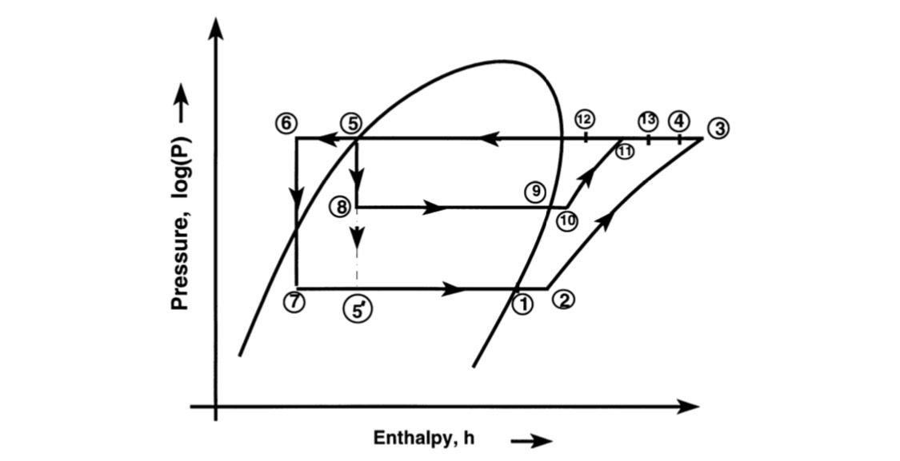

Figure :- Pressure-enthalpy diagram of an integrated mechanical -subcooling system.

At state 1 as a low pressure, low temperature saturated vapour and enter the main cycle compressor at state 2. the refrigerant, from state 1 to 2 takes heat from the surrounding in suction line. At state 3, it leaves the compressor as a high temperature, high pressure, superheated vapour. The refrigerated, from state 3 to 4, it mixes with the subcooler cycle refrigerated coming from the subcooler cycle compressor and attains state 13, and the mixture enters the condenser. The mixture after leaving the condenser is collected in the receiver. Some of this liquid refrigerant mixture is extracted from the receiver and is expanded in the expansion valve of the subcooler cycle and is then passed through the subcooler. The remaining liquid refrigerant in the receiver enter the subcooler, where it is cooled below the saturated liquid state at a constant pressure to state 6 by the subcooler cycle refrigerant. It enter the main cycle expansion valve and at state 7 it leaves the expansion valve as a low quality vapour and enter the evaporator. In the evaporator at a constant pressure to the saturated vapour state.

The subcooler-cycle refrigerant after cooling the main cycle refrigerant in the subcooler leaves as a low- pressure, low temperature, saturated vapor at state 9 and enter the subcooler cycle-compressor at state 10. The refrigerant from 9 to 10 Takes heat from the surroundings. At state 11, it leaves the compressor as a superheated vapor where it is mixed with the main cycle refrigerant coming from main cycle and attains state 13.

**3.2 ASSUMPTION**

Theoretical study of above system we need to assume some conditions that are pre-defined and makes it simple and easy for study following assumption are made.

1. All the heat exchanger used here namely evaporator, condenser and subcooler are working on isobaric process and they use air for cooling.
2. Here all the compressors that are used are working on isentropic process.
3. Expansion valves used in above setup are following isenthalpic process.
4. Temperature of evaporator (Te = 0degree C)
5. Temperature of condenser (Tc = 40degree C)
6. Degree of overlap = 5degree C
7. Degree of range = 5degree C
8. Degree of subcooling = 5degree C

**3.3 Theoretical formulation of IVCRS**

In this section, the working principle of IVCRS followed by its numerical model development from energy, exergy have been discussed.

Energy analysis: - energy analysis is based on energy conservation.

Mass equilibrium, = 0 (1)

Material equilibrium, = 0 (2)

Energy equilibrium, (3)

Exergy analysis: - It aids the recognition of the components which require design enhancement to lower their irreversibility.

Entropy generation during the process.

gen = out – sin –

After the determination of entropy generation in the process, the irreversible rate of any component can be found from Eq. (4).

(4)

Thermodynamic equation for different components of IVCRS.

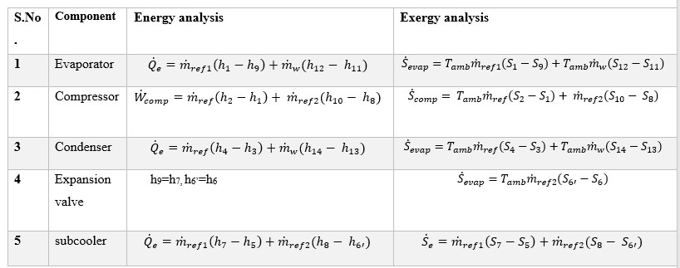

Table 1:- Thermodynamic equation for different components

**3.3 Fabrication of experimental setup**

The present setup consists of 3 major categories of components

1. Main components

2. Auxiliary components

3. Instrumentation

**Main components**:- these are the components which are primarily required to run the setup. following main components are used in the fabrication process:-

1. Evaporator

2. Compressor

3. Condenser

4. Subcooler

5. throttling device

6. capillary

**Evaporator:-** It is used to convert the liquid refrigerant into steam by the action of absorbing the heat from the surrounding or confined space. tube type evaporator is used in the setup. it is placed on the top of the setup & is itself the first component of the main cycle. air cooled evaporator is used in the setup.

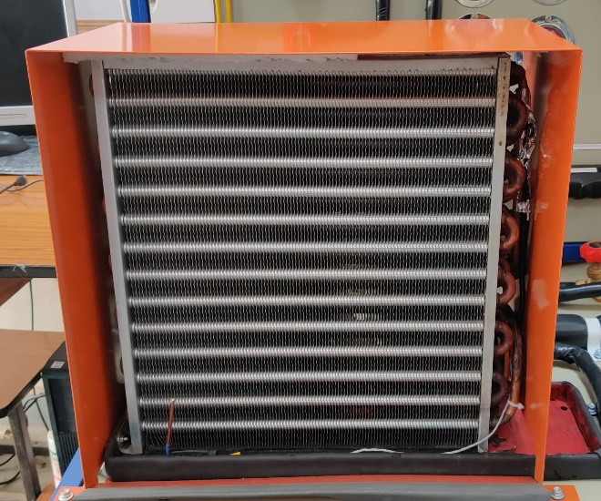

Figure :- Evaporator

**Compressor:-** It is a device which is used to increase the pressure and temperature of the refrigerant. reciprocating type hermatic compressors are used in the setup. there are 2 compressors used separately for 2 cycles i.e main cycle & subcooler cycle of 1tr and 1/3 tr respectively. specification for both compressors are as follows

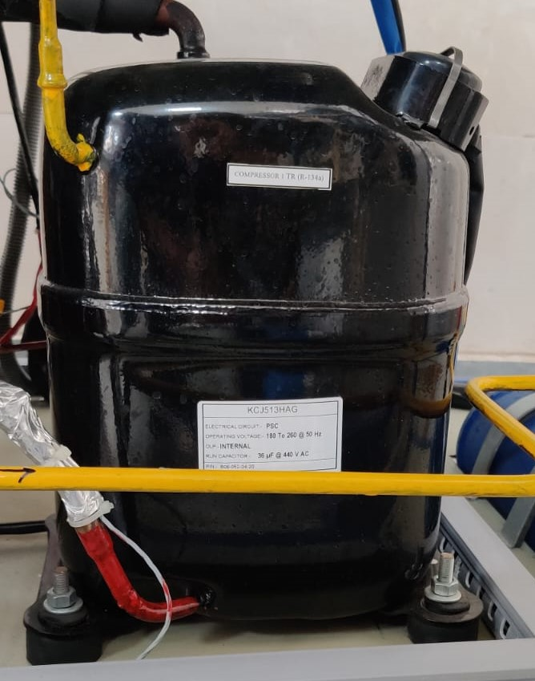

Figure :- Compressor 1 tr

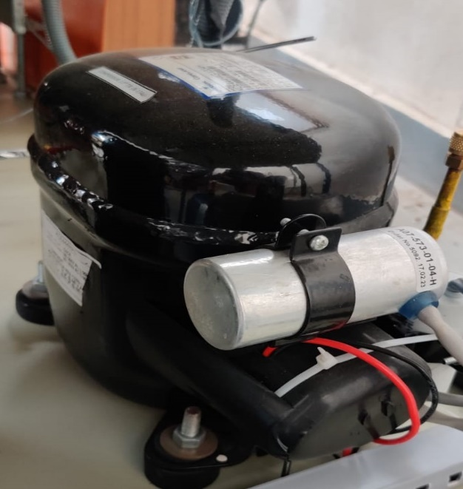

Figure :- Compressor 1/3tr

**Specifications for 1/3 tr Compressor**

|  |  |
| --- | --- |
| Model Name | KCE444HAG-VXXXH |
| Compressor type | Reciprocating ,Connecting Rod Type |
| Application group | High / Medium temperature (HBP / CBP) |
| Range | -17.8°C To 12.8°C (0° To 55°F) |
| Refrigerant | R-134a |
| Rated voltage | 230V, 50Hz, 1Phase |
| Certifications & approvals | ISI, EN60335-2-34. |

**Specifications for 1tr Compressor**

|  |  |
| --- | --- |
| Model Name | KCJ513HAE-B3XX |
| Compressor type | Reciprocating ,Connecting Rod Type |
| Application group | High temperature (HBP) |
| Range | -6.7°C To 12.8°C (20 °F To 55°F) |
| Refrigerant | R-134a |
| Rated voltage | 230 V, 50 Hz, 1 Phase |
| Certifications & approvals | ISI, EN60335-2-34 |

**Condenser:-** it is a heat exchanging device which is used to convert high temperature and high pressure refrigerant into low temperature and low pressure refrigerant by transferring heat of primary fluid into secondary fluid. tube type air cooled Condenser is used located just under the evaporator.

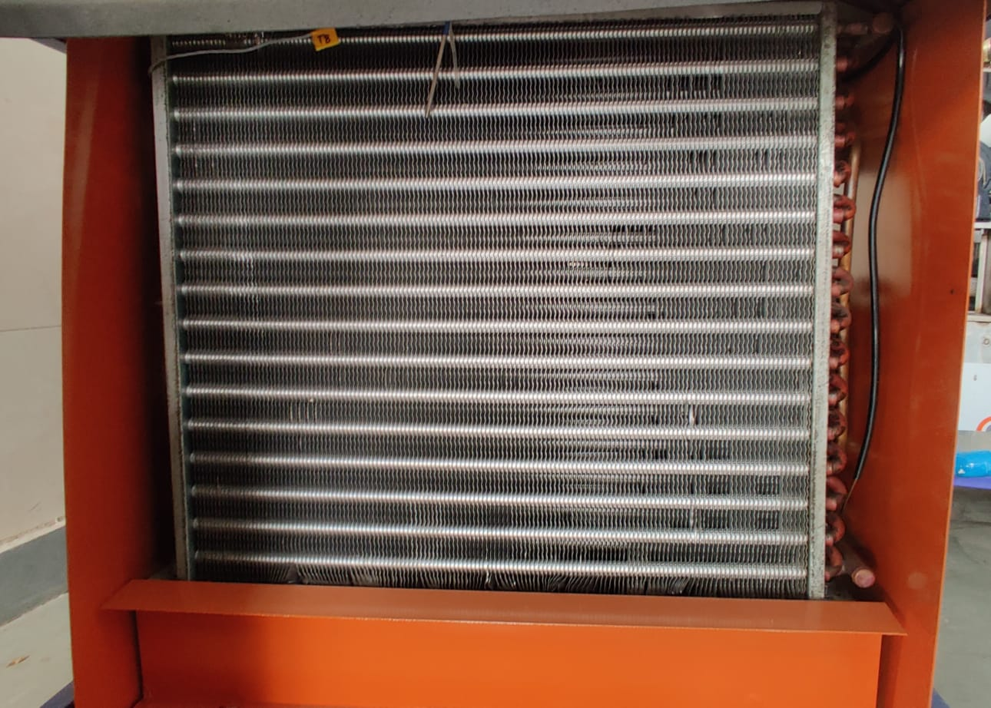

Figure :- Condenser

**Subcooler:-** device used to drop the temperature of refrigerant below the saturation point, total 2 Subcoolers are used in the setup, larger one is 600mm simple tube type cooler whereas smaller one is 350mm is provided with spiral tube arrangement. behind the evaporator both the Subcoolers are present.

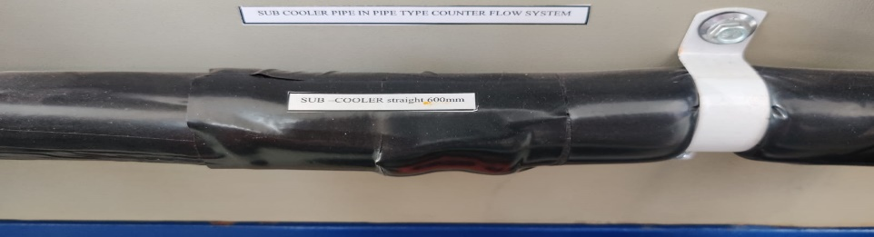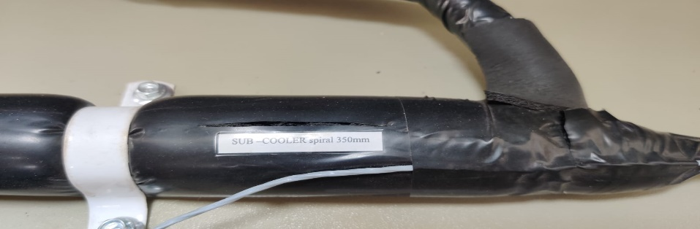

Figure :- Subcoolers

**Throttling device:-** this device is used to reduce the pressure of high pressure liquid refrigerant to attain pressure difference between evaporator & condenser, it basically absorbs the heat to attain the required cooling effect. in the setup both manual & capillary tube is used as throttling device. they are located before the evaporator & before the subcooler. for the manual working needle valves are used along with the solenoid valves.

**Capillary:-** it is tube with very less diameter and long length for the pressure drop to take place between the evaporator and condenser, where evaporator pressure is very low as compared to the condenser, there are two capillary in total in the setup, present just before the subcooler and the before the evaporator, length of both the capillaries are mentioned as follows capillary 1- 036x9ft and capillary 2- 055x760mm

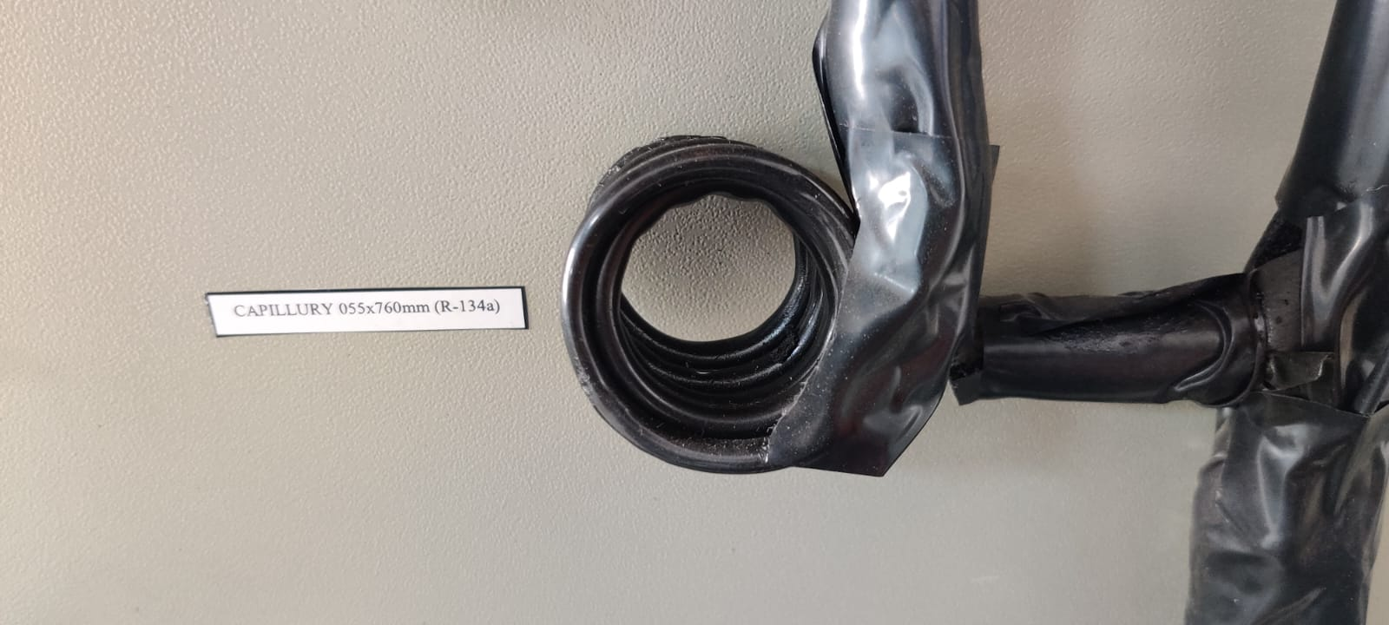

Figure :- Capillary

Auxiliary Components:- following auxiliary components are used in the setup

1. fans for evaporator and condenser

2. hand shut valves

3. solenoid valves

4. filter drier

5. sight glass

6. receiver tank

7. regulator for fans

9. refrigerant

10. insulation

**Fans for Evaporator and Condenser:-** for the proper functioning of the setup components must not attain very high temperature & must work in a certain limits, so for their cooling forced air cooling is used and fans are used for this purpose, there are total 2 fans used in the setup i.e they are present with the evaporator and the condenser. specification for the fan is as follows

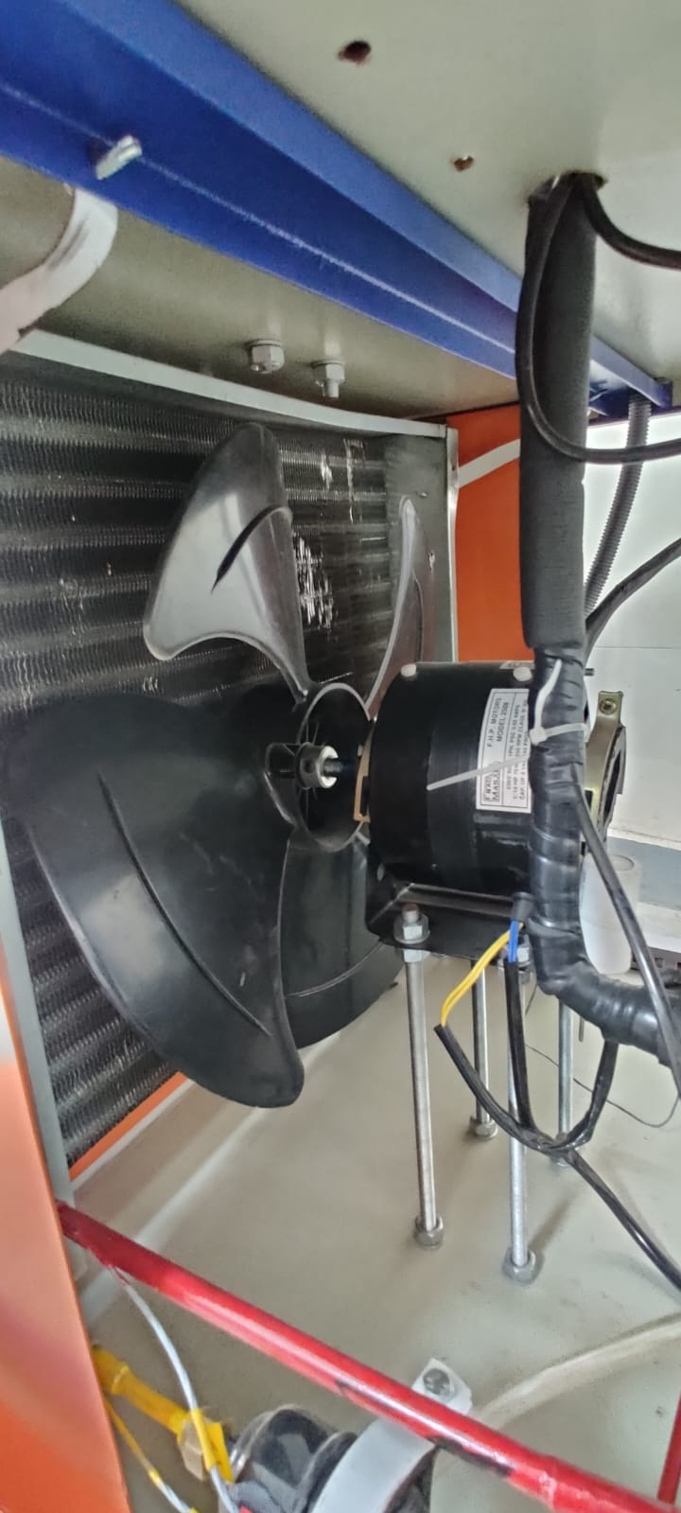

Figure :- Condenser Fan

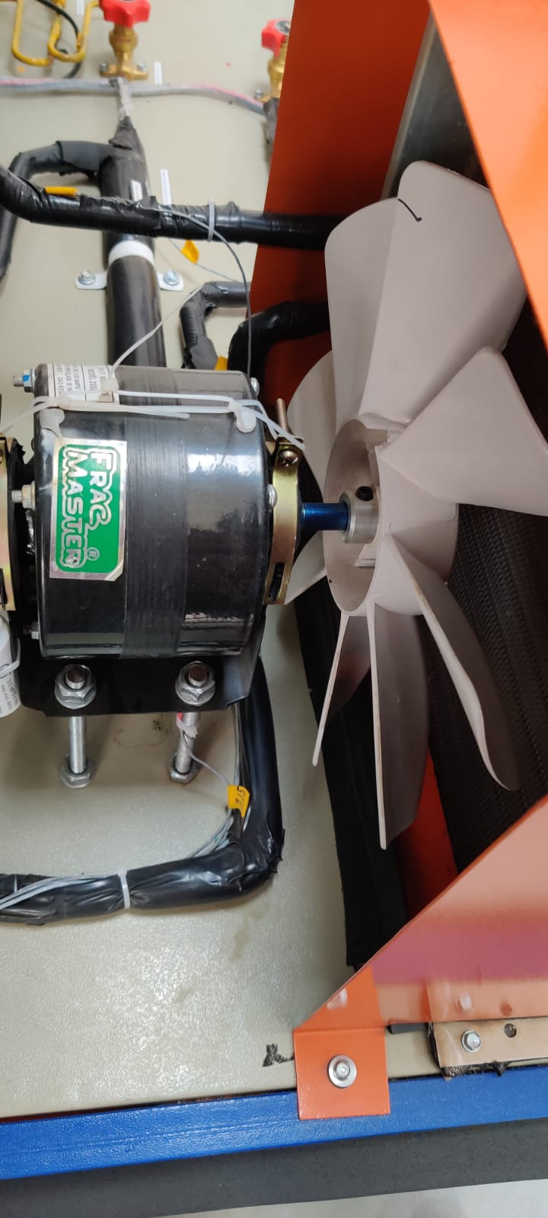

Figure :- Evaporator Fan

**Specifications of fan for Evaporator and Condenser**

|  |  |
| --- | --- |
| Model | F.H.P motors model 2508 |
| Voltage | 230v |
| Speed | 1350rpm |
| Current | 0.63amps |
| Phase | 1 phase |
| Power | 75w |
| Insulation type | class b |
| Frequency | 50 hz |

**Hand shut valves:-** It is used to control the flow of the refrigerant in the line. these are manually operated valves which allows the amount of refrigerant to flow in the line as per requirement, there are total 4 hand, there are total 4 hand shut valves in the setup, they allow the refrigerant to flow through the capillary tube.

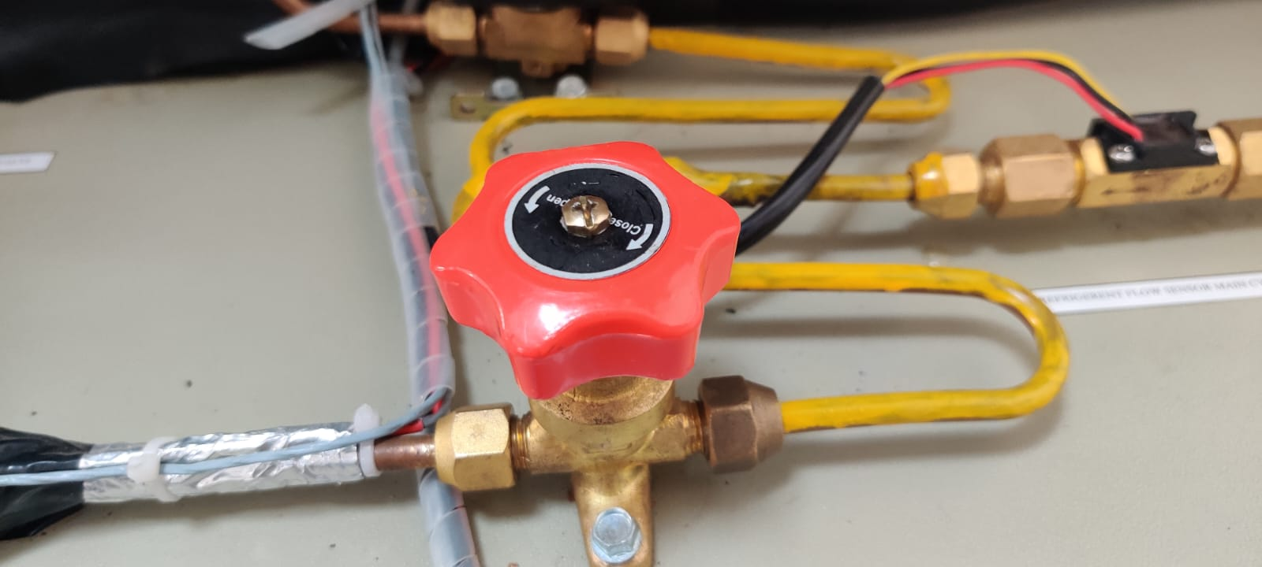

Figure :- Hand shut valves

**Solenoid valves:-** these are electromechanically operated valve and are the most frequently used control elements in fluidics, they shut off, release, mix or distribute the fluids, in the setup they are used for supply of fluid through needle valve manually. there are 3 solenoid valves used here located at back and front panel. specification for the solenoid valves are as follows

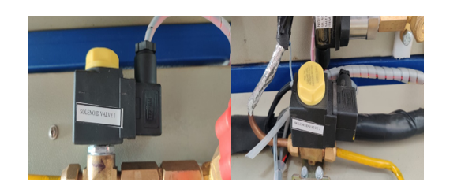

Figure :- Solenoid valves

Model :- SV1020/2

it is a two way, normally closed, poppet type, screw in hydraulic cartridge valve provided with manual and standard override motions.

**Filter drier:-** In the refrigeration system it is usually located in the liquid line. they basically they trap coarse particles, contamination and shavings of pipelines & secondary they prevent and moisture to enter the compressor. It is located just at the exit of condenser.

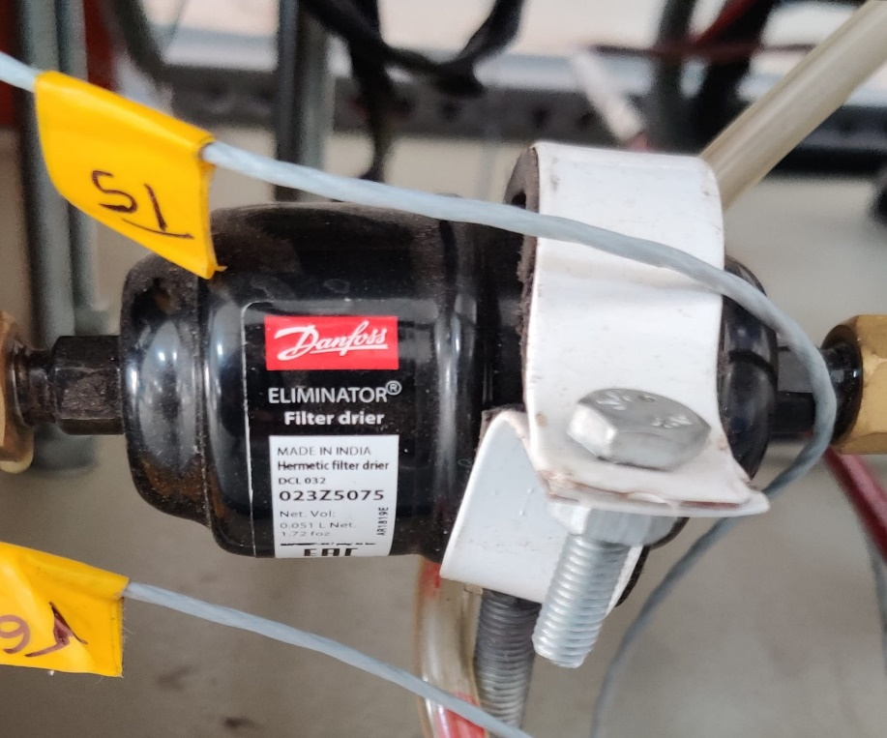

Figure :- Filter Drier

|  |  |
| --- | --- |
| Model | Danfoss eliminator 023z5075 |
| Type | Hermetic filter drier |
| Flow capacity [kw]R134a | 5.8 |
| Flow capacity [tr]R134a | 1.6 |
| Inlet connection size | 6 mm |
| Net volume | 0.051l |

**Sight glass:-** It is used to observe the flow of refrigerant that is leaving the condenser, that the fluid leaving the condenser must be saturated liquid only it is basically a water gauge which is transparent. it is placed on the line leaving the condenser after the filter drier which also helps in confirming that there is no such element in line which may abrupt the flow in the line.

**Receiver tank:-** it serves the function of controlling the flow of the refrigerant, adjusting as per the requirement i.e weather the temperature needs to be increased or decreased. it has a capacity of 2 kg & contains the refrigerant r-134a. it also serves the function of storing the excess refrigerant when not in use, it is situated in the bottom section of the setup, to right of the compressors.

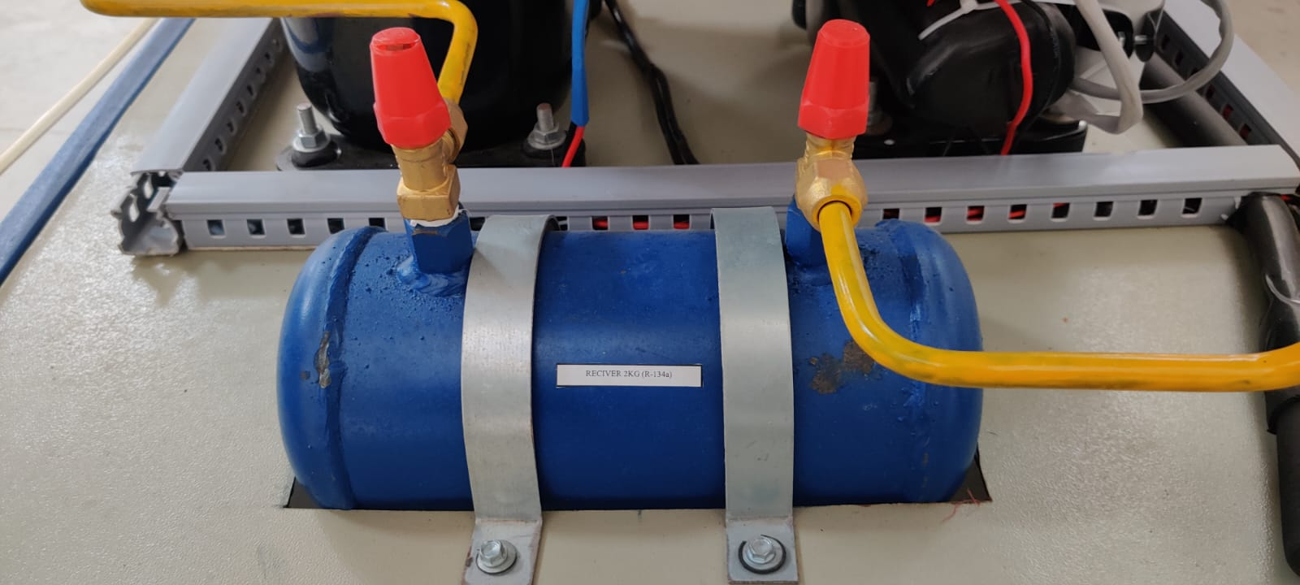

Figure :- Receiver Tank

**Regulator for fans:-** they are used to control the fan speeds situated at the condenser and the evaporator for adjusting the flow rate of the air as per requirements. It is situated at the top panel near the data logger system. pm cone 4 speed regulators are used in the setup.

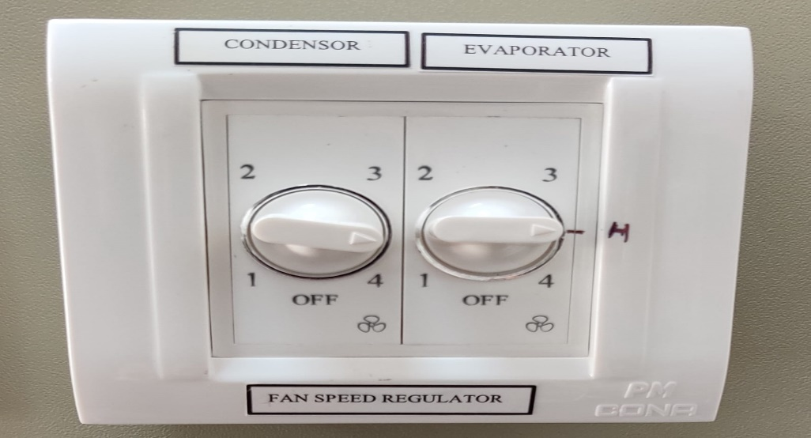

Figure :- Regulators

**Refrigerant:-** the working fluid in the complete integrated subcooled vcrs cycle is known as a refrigerant, it changes it's phase from time to time as the temperature of the system changes, it evaporates and attains the saturated vapor state after passing through the evaporator while passing through the condenser it attains the saturated liquid state. r-134a (tetrafluoroethene) (cf3ch2f) is being used in the setup. properties of refrigerant is as follows

|  |  |  |
| --- | --- | --- |
| No | Properties | R-134a |
| 1 | Boiling Point | -14.9°F or -26.1°C |
| 2 | Auto-Ignition Temperature | 1418°F or 770°C |
| 3  4 | Ozone Depletion Level  Solubility In Water | 0  0.11% by weight at 77°F or 25°C |
| 5 | Critical Temperature | 252°F or 122°C |
| 6 | Cylinder Color Code | Light Blue |
| 7 | Global Warming Potential (GWP) | 1200 |
|  | | |

**Insulation:-** it prevent the heat loss to take place from the pipeline. all the major pipelines which are used for the transfer of the fluid. this can be seen all over the setup in black color, with the use of this allover performance of the system is enhanced.

**Instrumentation:-** following instrumentation is being used in the setup fabricated

1. temperature sensors

2. pressure transducers

3. mass flow sensors

4. energy flow meter

5. data aquisition system

6. overload protection switch

7. main supply on/off

8. fuse holder

9. all display units

10. analog pressure gauges

**Temperature sensors:-** these are used for sensing temperatures at various set points. there are 19 temperature sensors in total installed at respective places in the setup. thermocouples are used for sensing the temperatures. we get to know the temperatures accurately for the proper analyzation of setup and obtaining results, it measures the setup temperature as well as ambient temperature in degree Celsius. recorded temperature could be seen in multispan uti 38 display installed at the back panel.

**Pressure transducers**:- same as of temperature sensors we are able to measure the pressure at various set points. there are respectively 11 sensors for the accurate measurement. we get the measurement in BAR. These are evenly distributed in the setup at various location. same as of temperature sensors pressure recordings is also shown in the multispan uti 38 display. specification of pressure transducer are

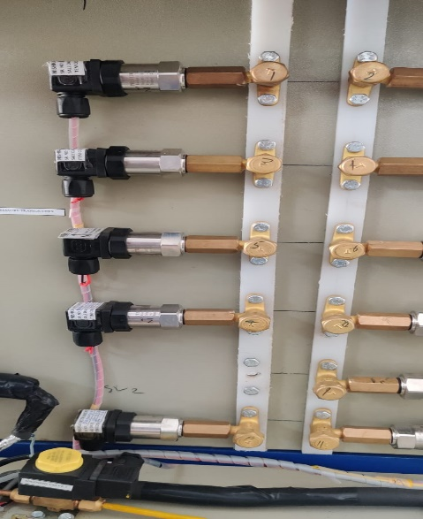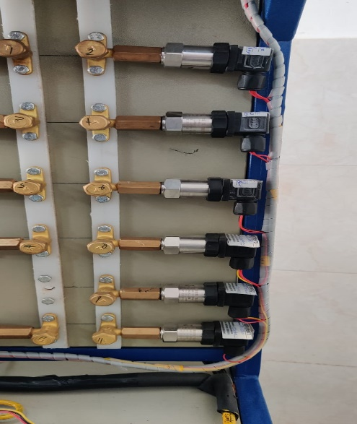

Figure :- Pressure Transducers

|  |  |
| --- | --- |
| Brand | Nishka instruments |
| Item code | Pt-40-bar |
| Range | 0-40 bar |
| Output | 4-20 ma |
| input | 12-30 bdc |
| bump | 2211090b07 |

**Mass flow sensors:-** refrigerant from the receiver tank comes and is further distributed in the main cycle & subcooler cycle, for the measurement of flow of refrigerant in these two sensors are used, mass flow rate is measured in litre/min these are just aside to the solenoids valves present on the top panel. there are a total of 2 sensors provided in the setup.

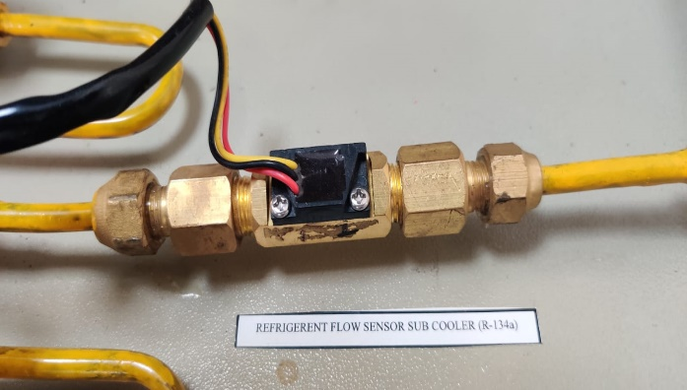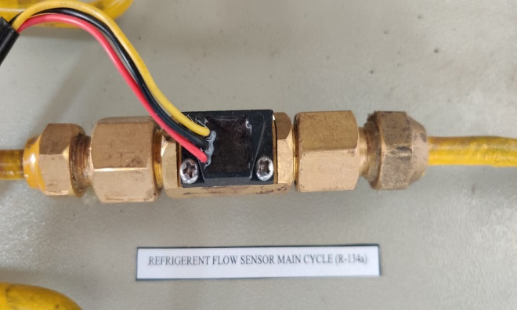

Figure :- Mass Flow Sensors

**Energy flow meter:-** there are respectively 2 energy meters present in the setup at the top if the panel in the rightmost corner. these show the energy consumption by both the compressors in KWH i.e for 1tr and for 1/3 tr compressor. single phase 2 wire energy meters are used for the consumption reading. specification of the energy meter is as follows

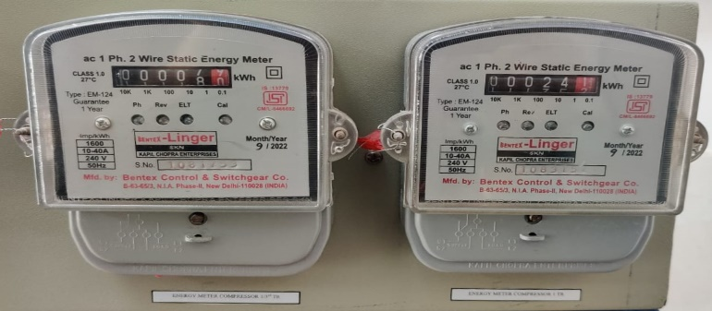

Figure :- Energy Flow Meter

|  |  |
| --- | --- |
| Brand | rc bentex |
| Accuracy class | 1 |
| Current rating | 10-40a |
| Display type | counter |
| Frequency | 50hz+5% |
| No. of wires | 2 |
| Phase | single phase ac |
| Test voltage at 50hz for 1 minute | 4kv rms |

**Data aquisition system:-** the unilog pro plus data logger is the system used for collecting all pressure and temperature sensor data. the system is responsible for sending all data out to computer. a software named prolog is used to fetch data from the apparatus. whole system is together. specifications of the system are as follows

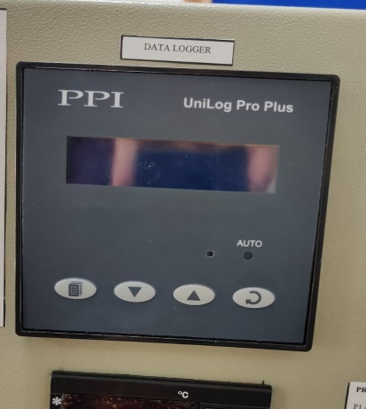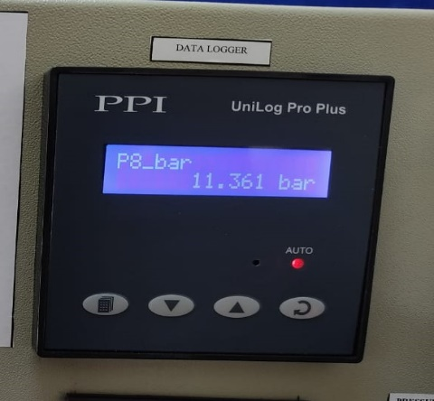

Figure :- Data acquisition System

|  |  |
| --- | --- |
| model name | unilog pro plus |
| type of data logger | digital data logger |
| parameter to be monitored | temperature |
| export of data | excel |
| display | 2 rows of 16 characters lcd display with back-light led |
| dimension | 96 X 96 X 65 mm ( h x w x d ) |
| brand | ppi |
| no. of channels | multichannel |
| input resistance | 8 mohm |
| signal conditioning | l-c analog filter |
| connections | screw type |
| recording mode | continous |
| mounting | panel mount |
| Sampling Time | 500mS Per Second |
| Keys | 2 Tactile Switches |

**Overload protection switch:-** it is a safety device which cut off the supply when the pressure of the system exceeds the defined limits. it usually prevents the setup from catastrophic failure. it is present at the back panel. lp/hp pressure cut is used to help the setup to run in the safe conditions following are the specifications of the "lefoo lf58 series"

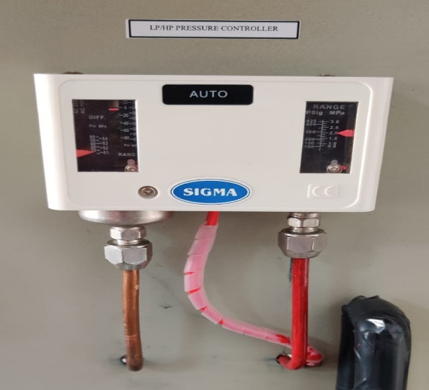

Figure :- Overload Protection Switch

|  |  |
| --- | --- |
| Brand | lefoo |
| Series | Lf58 |
| Compatible medium | Freon, air, fluid, non corrosive medium |
| Lf5832 range | -0.2/7.5 bar & 8-32 bar |
| Lf5832hm range | -0.2/7.5 bar & 8-32bar |
| Lf5832hlm range | 0.2/7.5 bar & 8-32 bar |
| Connection arrangement | spdt |
| Media temperature | -20-110 dec c |
| Full load | 50va |
| Locked roter | 4a |

**Main supply on/off:-** It is used to operate the setup by providing the supply it. havells dp c 32 mcb is used. It is present at topmost left section of the setup. It prevents the failure by cutting the main supply. home safe series is used in the setup, specifications of the following is as follows

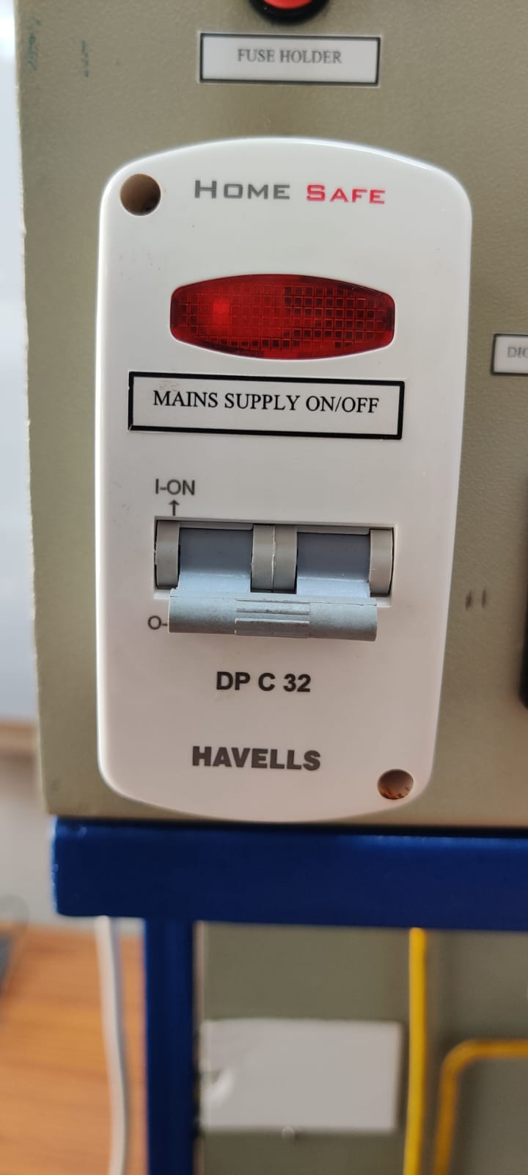

Figure :- Main Supply on/off

|  |  |
| --- | --- |
| Brand | Havells |
| Current Rating | 63 Amps |
| Item Dimensions lxwxh | 44.5 x 40.8 x 24 Centimeters |
| Circuit Breaker Type | mcb |
| Mounting Type | wall mount |

**Fuse holder:-** Holder:- it is used to integrate fuses in electrical circuits, it ensure a robust current path and provides a method to replace fuses once they perform their duties. It is present at top of the setup just above main supply on/off.

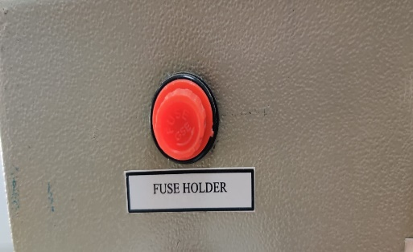

Figure :- Fuse Holder

**All display units:-** all the display unit are used for showing different pressure and temperature data. the display unit include unilog display , voltage display, current display for 1/3 TR and current display for 1 tr compressor. display unit contains multispan voltage meter model number av 31v, amps meter compressor 1/3 tr model number av 34, amps meter compressor 1 tr model number av 31a, multispan uti 38 for room temperature measurement, temperature time delay controller for 1 tr compressor model number sz-7569-p.

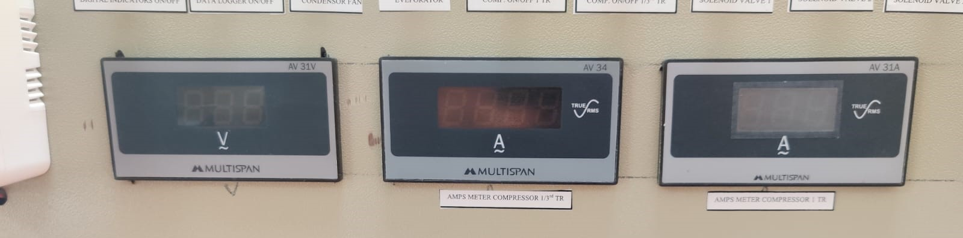

Figure :- All Display Units

**Analog pressure gauges:-** analog pressure gauges are present in the setup for observing the pressure of the system manually, there are total of 4 analog pressure gauges, 2 for measuring low pressure and two for high pressure, each for 1tr and 1/3 tr, red color indicates high pressure and blue color represents low pressure, specifications of the following are

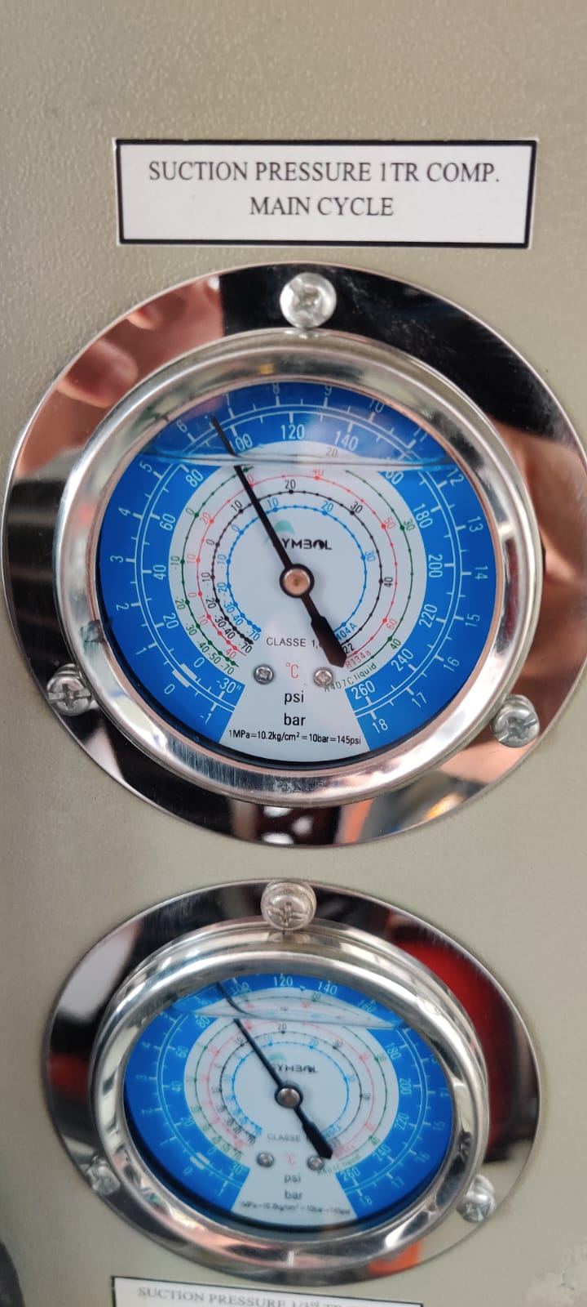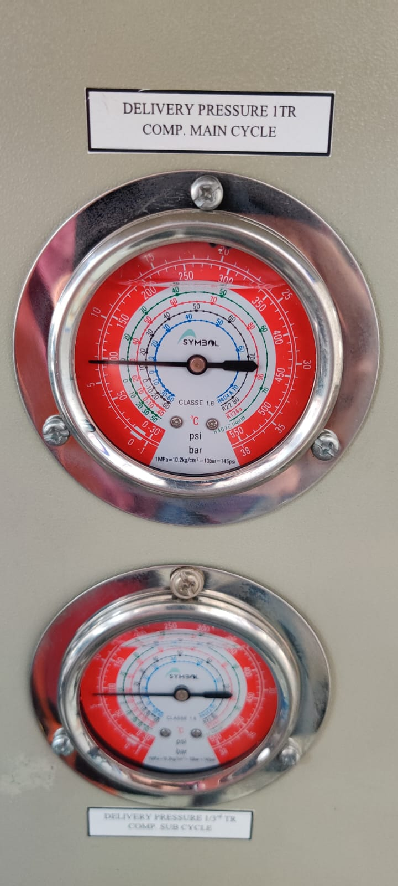

Figure :- Analog Pressure Gauges

|  |  |
| --- | --- |
| Model no. | 1.8 mpa- 3.8 mpa |
| Indicating pressure reference | general pressure gauge |
| Features of measurement medium | general pressue gauge |
| Installation structre | direct mounting |
| Function | local indication type |
| Connection type | axial |

**3.4 working of experimental test facility**

In this section, the working of the experimental setup is explained. The Refrigerant leaves the evaporator section (State 1). The Refrigerant leaves the evaporator at low temperature and low pressure and travels to the bigger compressor(1 TR) in the main cycle. While passing through the suction line, the refrigerant tends to collect heat from the surroundings. At State 5, after leaving the compressor, the refrigerant is superheated vapor and is at high pressure and high temperature. While traveling in the discharge line, it tends to release heat to the surroundings.

Furthermore, the main cycle refrigerant meets with the subcooler cycle refrigerant, which is coming from the subcooler cycle compressor of capacity 1/3 TR (State 4). After meeting, the refrigerant enters the condenser (State 6) where the temperature of the fluid is reduced. It then travels to the filter/drier placed just after the condenser, where unwanted particulate or coarse particles are removed. This could be observed through the sight glass placed just after the filter drier. Then, the refrigerant is collected in the receiver tank of capacity 2 kg, where the refrigerant is divided into two mass flow streams, one for the main cycle and the other for the subcooler cycle.

There are two mass flow sensors present, which are used to measure the amount of refrigerant passing through each circuit. For the subcooler cycle, the fluid is expanded, i.e., the temperature and pressure of the refrigerant are reduced to a certain limit. There are two methods of doing so, either by the solenoid valve , which allows the user to adjust the needle valve to meet the required cooling, or by the capillary tube present, which can't be altered manually and drops the temperature and pressure to a standard value. After passing through the Expansion Valve, it further travels to the subcooler . The setup is provided with two subcoolers. One with 350mm length and other with 600 mm length. We have the liberty to choose the subcooler according to the specified configuration.

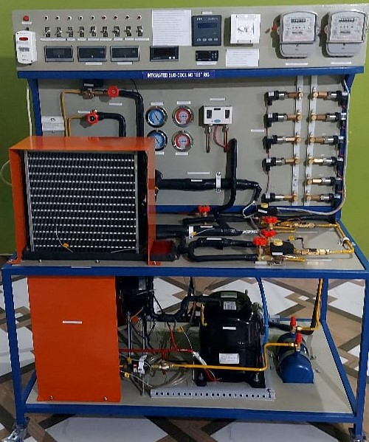

Figure :- Working Setup